# Game Ideas and rough plan

Colour Bandits

Genre: 2D RPG Puzzle Platformer Metroidvaina

Fill the world with colour

Player has paintbrush/paintgun and has to colour the world as they progress through puzzles

Player can only walk on coloured platforms

Avoid colour removing enemies

Difficulty levels affect player health & damage

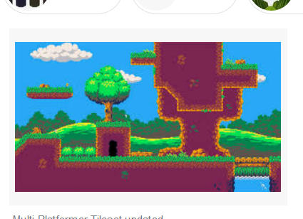Assets required will be 8-bit simple Assets, mostly grassland type

Interface will have player health top left

Player score/collectables top middle (paintcans?)

Timer in top right for how long player takes to complete the level?